

Laboratory work #2

Performance, Data Structure & Algorithms

“Merge sort”

Group:ITDS-1901

Ibrayeva Madina

Illustrate the operation of merge sort on the array A = (3; 41; 52; 26; 38; 57; 9; 49).

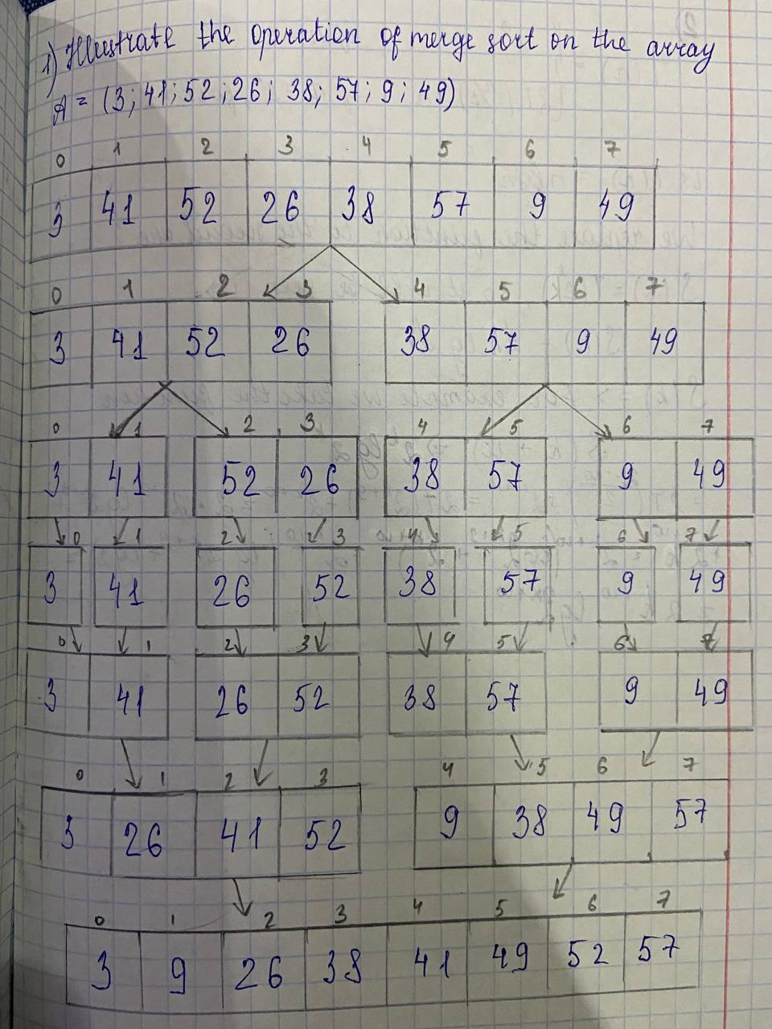

Rewrite the MERGE procedure so that it does not use sentinels, instead stopping once either array L or R has had all its elements copied back to A and then copying the remainder of the other array back into A.

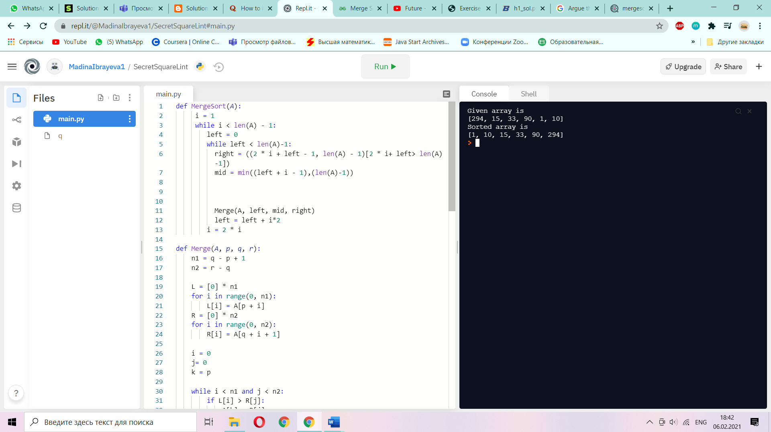 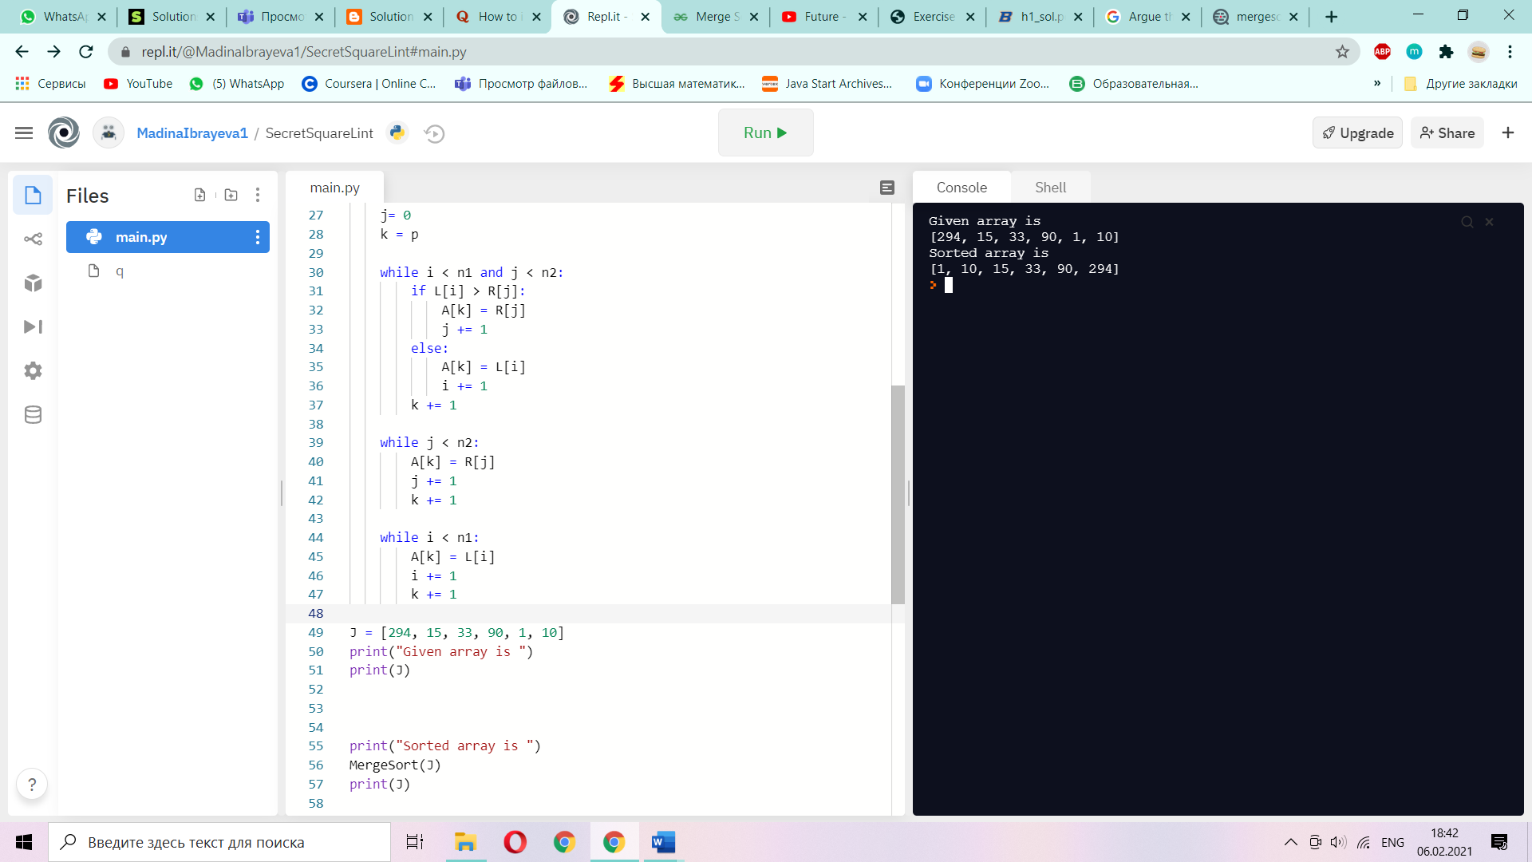

i=1

while i<A[A.length]-1

left=0

while left<A[A.length]-1

right=((2\*i+left-1,A[A.length]-1)[ 2\*i+left-1 > A[A.length]-1])

mid=min((left+i-1),(A[A.length] -1))

def Merge(A,p,q,r)

n1=q-p+1

n2=r-q

L[], R[], L.Merge, R.Merge

while i<n1 and j<n2

if L[i]>R[j]

A[k]+R[j]

else

A[k]=L[i]

while j<n2

A[k]=R[j]

while i<n1

A[k]=L[i]

We can express insertion sort as

a recursive procedure as follows. In order to sort A(1,…,n,) we recursively sort A(1,…,n-1) and then insert A(n) into the sorted array A(1,…,n-1). Write a recurrence for

the running time of this recursive version of insertion sort.

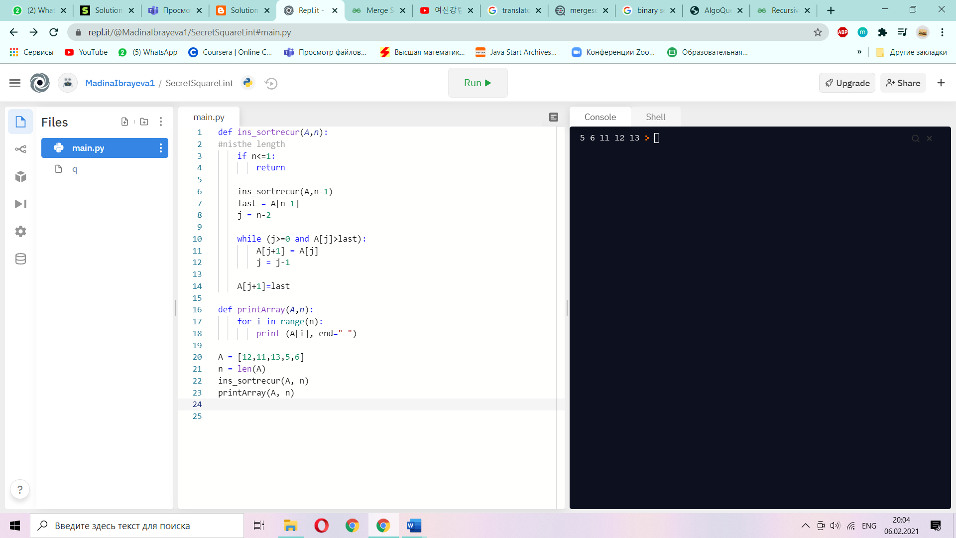

def f(A, n)

if n<=1:

return

f(A,n-1)

last = A[n-1]

j=n-2

while(j>=0 and A[j]>last)

A[j+1] = A[j]

A[j+1] = last

Referring back to the searching problem (see Lab 1), observe that if the sequence A is sorted, we can check the midpoint of the sequence against and eliminate half of the sequence from further consideration. The binary search algorithm repeats this procedure, halving the size of the remaining portion of the sequence each time. Write pseudocode, either iterative or recursive, for binary search. Argue that the worst-case running time of binary search is O(n\*lg n).

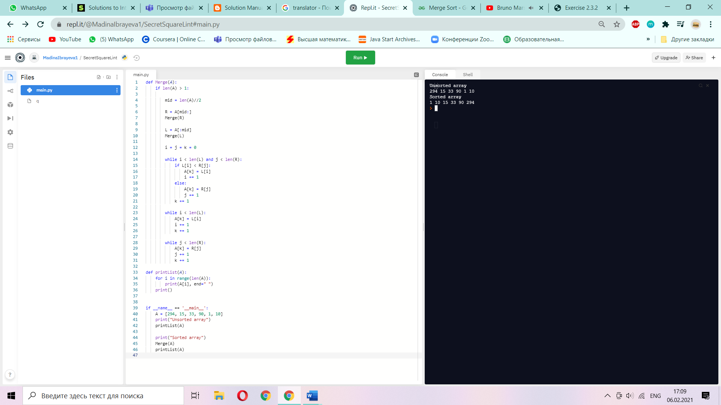

if A[A.length] >1

mid = A[A.length]/2

R = A[mid:]

L=A[:mid]

while i<L[L.length] and j<J[J.length]

if L[i]< R[j]

A[k] = L[i]

else

A[k] = R[j]

while i<L[L.length]

A[k] = L[i]

while j<J[J.length]

A[k]=R[j]

Use mathematical induction to show that when n is an exact power of 2, the solution of the recurrence

